Configure robot framework in Jenkins

1. login Jenkins <http://10.27.144.12:8080/>

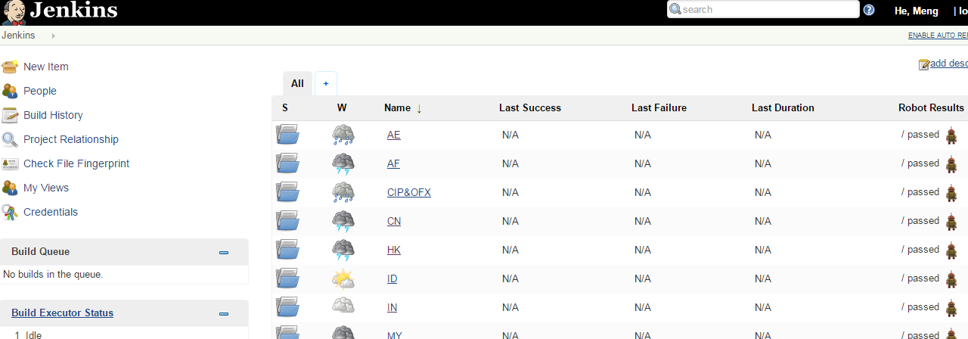

1.create new item or create new job

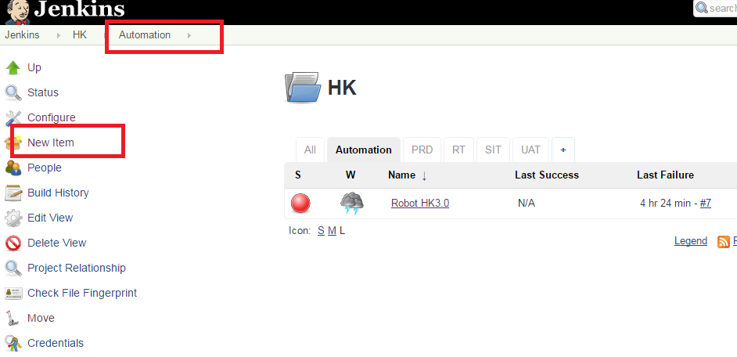

1.1

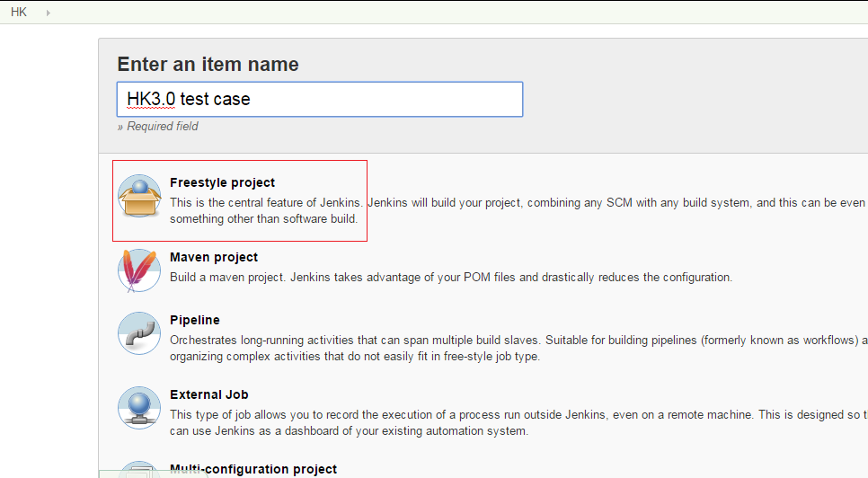

1.2

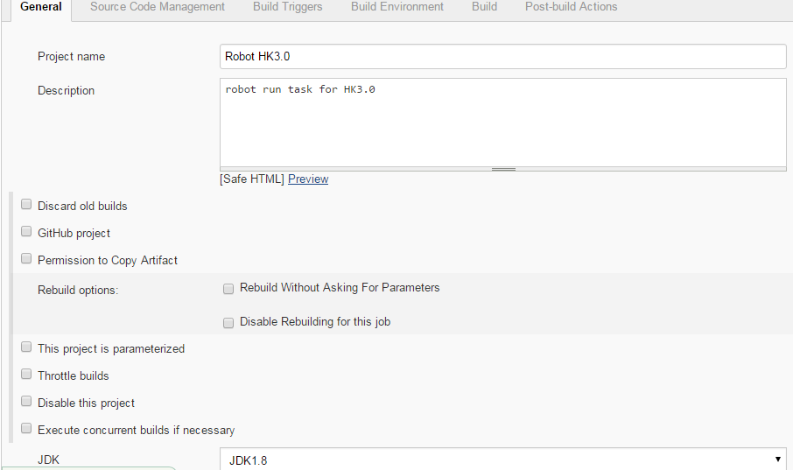

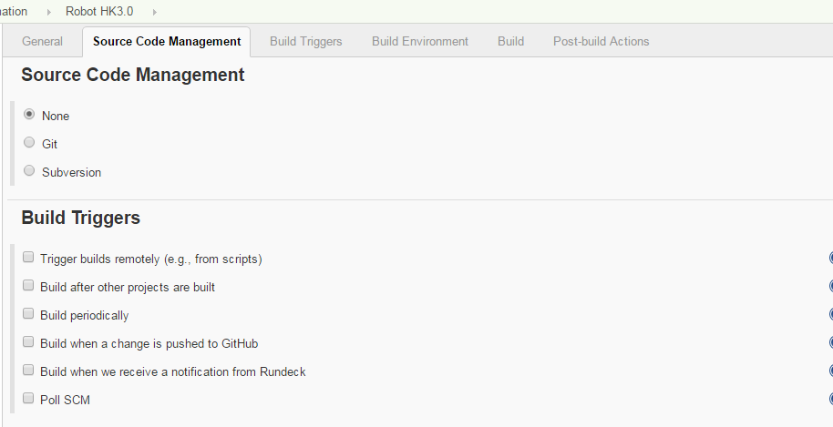

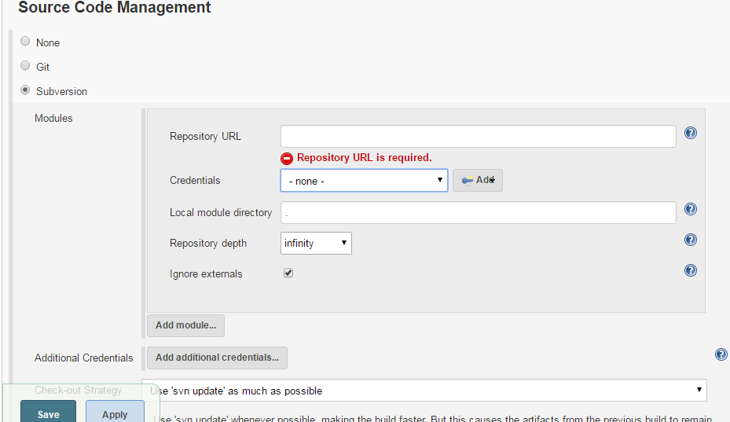

If case resource is in local machine of Jenkins, select none;

If in svn, select Subversion, and input resource path in SVN in Repository URL; add your SVN login ID and password.; leave others default;

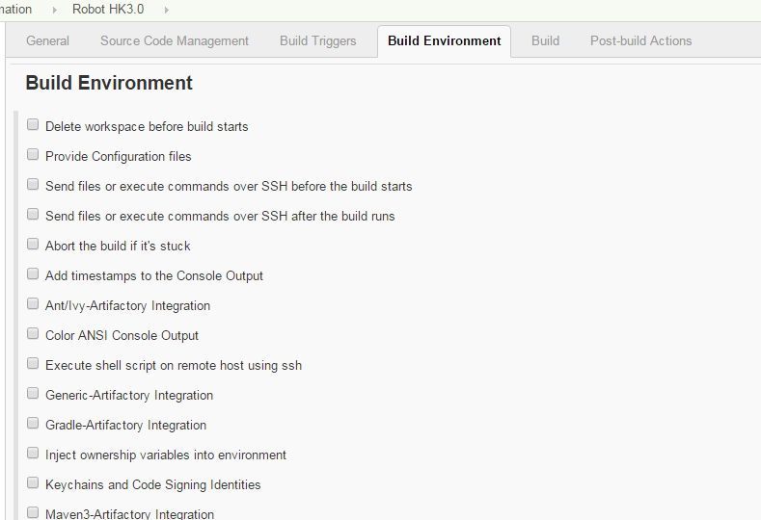

Build environment: according to your needs to setup; if no special requirements, keep it blank;

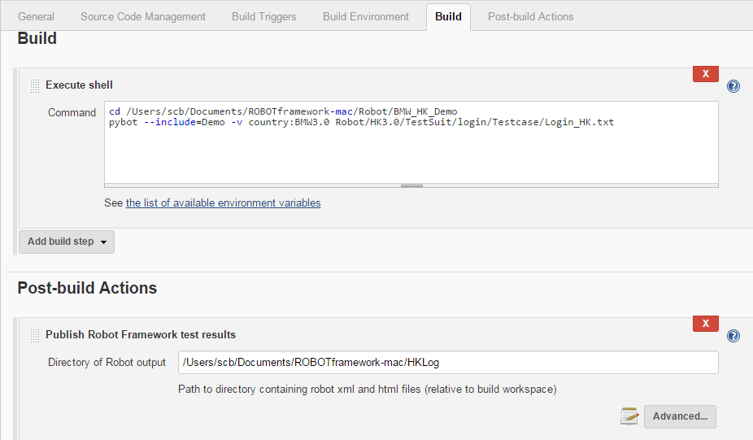

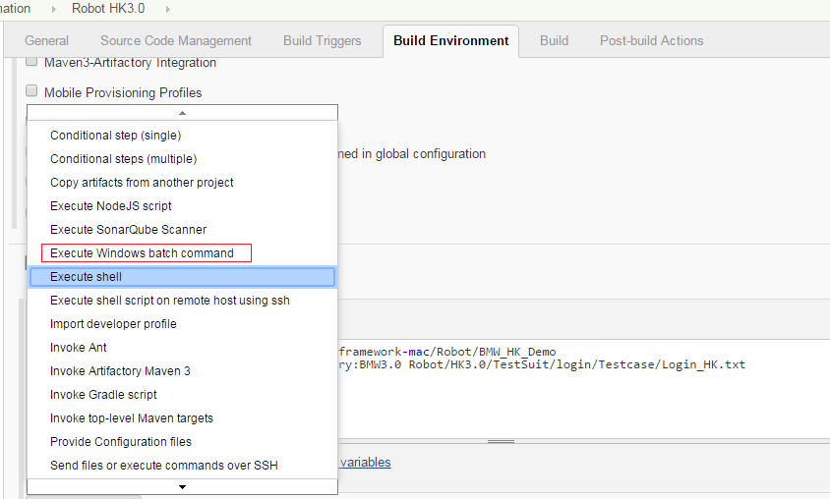

Build: input command to run test cases. In terminal, Must firstly go to the root directory folder (you can check in ride GUI, the root directory), Then input ‘pybot ‘command. For example:

cd /Users/……/BMW_HK_Demo

pybot –include=Demo –v contry:BMW3.0 Robot/HK3.0/Testsuit/Login/Testcase/Login_HK.txt

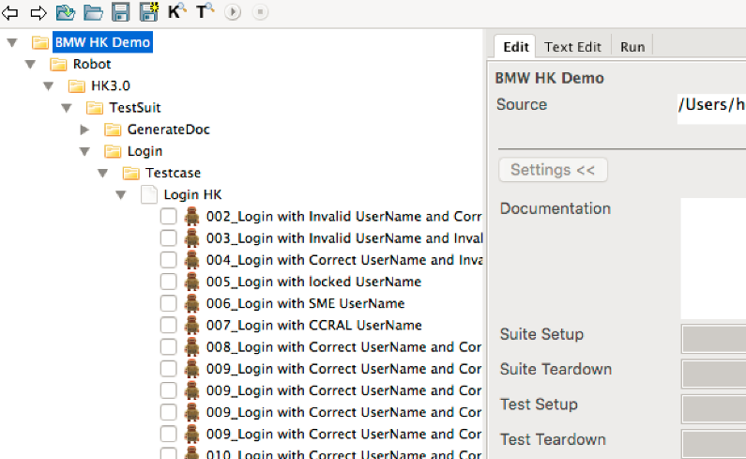

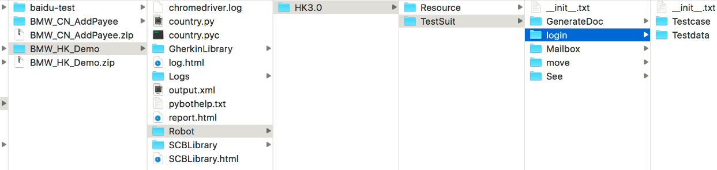

In MAC, select execute shell;

If in Windows system, select execute Windows batch command.

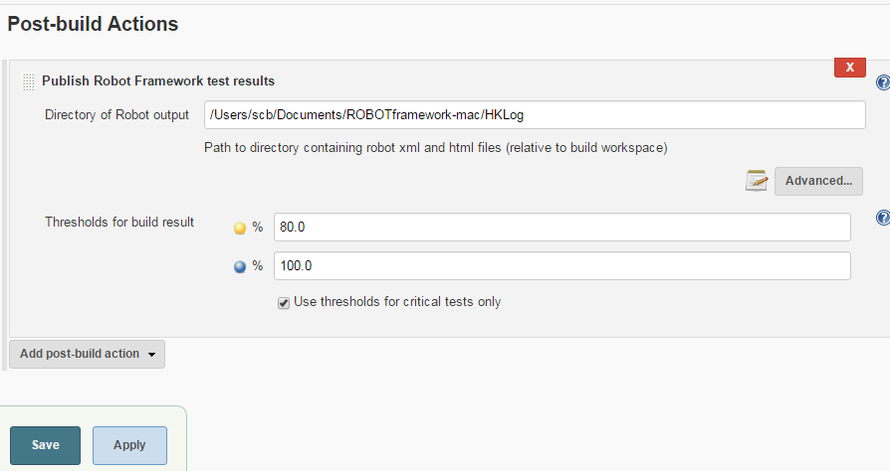

This step is to setup some action after building. Enter the output.xml path in ‘Directory of Robot output’, system can find the output.xml and parse the contents, then can give the report .

2.create new view

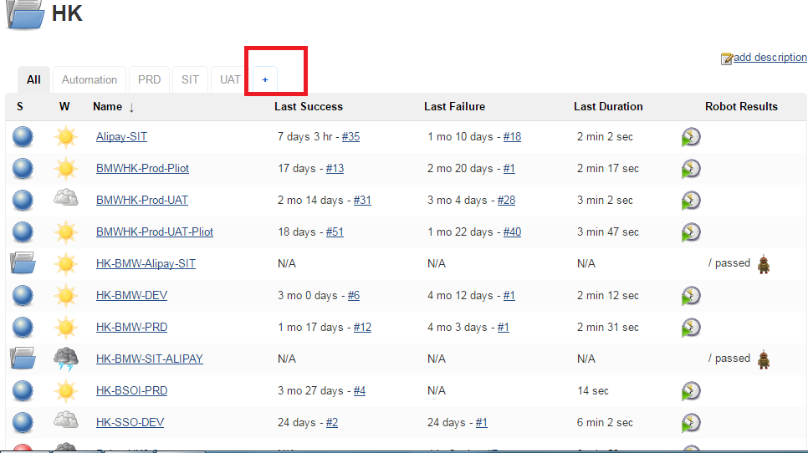

2.1

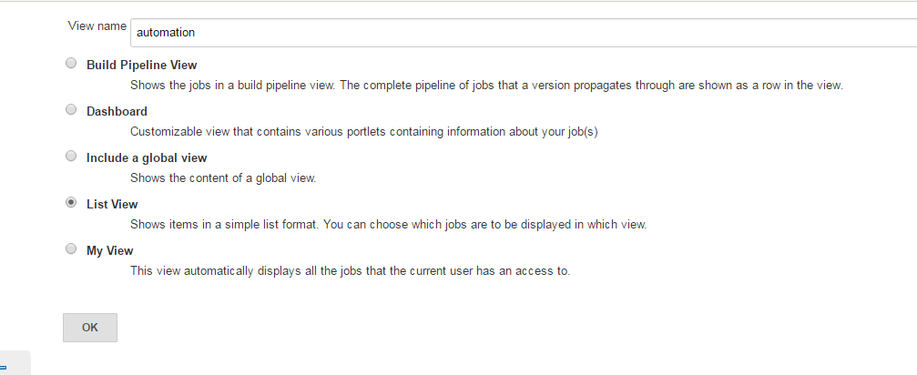

2.2

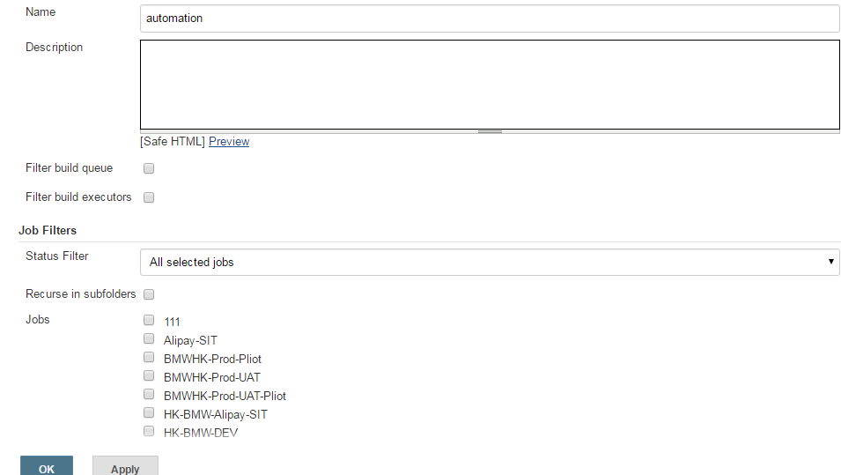

Input view name, select List view type. can tick the job you need in the dropdown list , then the job will display below the tab view.

Note:

Pre-configure: RF plugin,

1) in system management>advance , upload .hpi document,

RF plugin download path: <http://mirrors.jenkins-ci.org/plugins/robot/>

2)system management>installed, search Robot Framework plugin

3.run test case

